CWT Customization
Version 8.0

Copyright | Program copyright ©Global Implementation Services, Inc. Portions of this software are copyrighted by ©2004 Microsoft Business Solutions. All Rights Reserved. This work and the computer programs to which it relates are the property of, and embody trade secrets and confidential information proprietary to Global Implementation Services, Inc., and may not be reproduced, copied, disclosed, transferred, adapted or modified without the express written approval of Global Implementation Services, Inc.  Manual copyright © Global Implementation Services, Inc. All rights reserved. This document may not, in whole or in part, be copied, photocopied, reproduced, translated, transmitted or reduced to any electronic medium or machine-readable form without prior consent, in writing, from Global Implementation Services, Inc.
Trademarks | Great Plains, Dynamics and eEnterprise are trademarks of Microsoft Business Solutions.  Other company or product names mentioned may be trademarks or registered trademarks of their respective holders.
Warranty | Global Implementation Services, Inc. warrants that upon delivery, the software will substantially conform to the documentation for it, provided it is properly used on the computer hardware and with the operating system for which it was designed. Global Implementation Services, Inc. also warrants that the software will be properly copied onto the disks and that the disks on which the program is recorded will be free from defects in materials and workmanship under normal use and service for 90 days from the date the software is delivered to you. If you have properly registered your copy of the program directly with Global Implementation Services, Inc., defective disks or documentation will be replaced or substantial nonconformities between the software and its documentation will be corrected at no charge, provided you return the item and a copy of the paid receipt to Global Implementation Services, Inc. within 90 days after delivery. Your only remedy in the event of a defect in the program, documentation, or disk or for breach of any warranty is repair or replacement of the item as provided above.
Limitation of Liability | The content of this manual is furnished for informational use only, is subject to change without notice, and should not be construed as a commitment by Global Implementation Services, Inc. Global Implementation Services, Inc. assumes no responsibility or liability for any errors or inaccuracies that may appear in this manual. Neither Global Implementation Services, Inc. nor anyone else who has been involved in the creation, production or delivery of this documentation shall be liable for any indirect, incidental, special, exemplary or consequential damages, including but not limited to any loss of anticipated profit or benefits, resulting from the use of this documentation.
License Agreement | Use of this product is covered by a license agreement provided by Global Implementation Services, Inc. with the software product.
Publication Date | February 2006

Contents
Introduction 1
What’s in this Manual 1
Symbols and conventions 1
Target Audience 2
Chapter 1: Setup 3
Installing the CWT Customization Module 4
Table Creation 5
User Security 5
Module Registration 6
Setup the CWT System 7
Account Setup 9
Chapter 2: Working with CWT Customization 11
Apply CWT 12
Multi-rate CWT 16
CWT Inquiry and Monitoring 17
Chapter 3: Generating CWT Customization Reports 18
Generating Reports 19
Documentation Comment Form 20

Introduction
Welcome to the CWT Customization, part of the enhancement options for Microsoft Great Plains made available by Global Implementation Services, Inc. (GIS). The CWT Customization is designed to meet all Creditable Withholding Tax specific requirements of the customer in the Philippine business environment.
The Customization features the following:
- Default CWT rate is maintained
- A single sales invoice can have multiple CWT rate
- Flag apply to sales documents that are subject to CWT and CWT is auto computed
- User can partially apply payment for an invoice
- CWT Inquiry and Monitoring window is designed for marking the CWT records with certificate and outstanding, this includes feature for filtering records and facility to print the report.
- Auto lock records with certificates after a specified length of time
This introduction is divided into the following sections:
- What’s in this manual
- Symbols and conventions
- Target audience

What’s in this Manual
This manual is designed to give you an in-depth understanding of how to use the features of CWT Customization.
The manual is divided into the following chapters:
Chapter 1, “Setup,” explains how to configure CWT Customization into your existing Great Plains system.
Chapter 2, “Working with CWT Customization,” shows the functionality of CWT Customization.
Chapter 3, “Generating CWT Customization Reports,” elaborates the where and how the reports in CWT Customization are generated.

Symbols and conventions
This manual uses the following conventions to refer to different sections, emphasis and other information.
Symbol | Description
 | The light bulb symbol indicates helpful tips, shortcuts, and suggestions
 | The warning symbol indicates situations you should be aware of when completing tasks. Typically, this includes cautions about performing steps in their proper order or important reminders about how other information in the system may be affected.

Convention | Description
Creating a Batch | Italicized type signifies the name of a section or chapter within the user guide.
File>>Print | The >> symbol indicates a sequence of actions, such as choosing items from a menu or toolbar, or pressing buttons in a window. This example tells you to go to the File menu and Click Print.
TAB OR ENTER | Small capital letters in bold indicate a key or a key sequence

Target Audience
The CWT Customization is to be used by Dynamics and eEnterprise end-users and administrators having basic to advanced knowledge in the operations of the systems. The manual provides end-users with the procedures and steps on how to utilize the CWT Customization. For administrators, the manual gives instructions on how to install and properly configure the module.

Chapter 1: Setup
The CWT Customization must be properly installed before you can start utilizing its features. This chapter tackles how to quickly install the module into your current Dynamics or eEnterprise system.
In this section, you’ll learn:
- How to install the CWT Customization chunk into your current system
- How to add create tables, grant/remove user access, and register the module.
- How to setup the CWT system by creating tax details and tax schedules for VAT as well as creating CWT setup.

Installing the CWT Customization Module
The CWT Customization module is installed by copying an installer file known as a “chunk” directly into the Microsoft Business Solutions - Great Plains directory. After copying the file, start Great Plains to setup the CWT Customization.

You must be logged in as “sa” to perform the installation and no other applications must be running.

To install the CWT Customization module:
- Insert the installation disk into the CD drive then double click on My Computer. The My Computer window will be displayed.
- Double click the CDROM Drive. The CD Drive window will be displayed.
- Copy the chunk file to your Great Plains directory.
This file has an extension name of .CNK.
- Start the Microsoft Business Solutions - Great Plains. A dialog box will appear informing you that a new code was found and inquiring if it should be included in the dictionary.
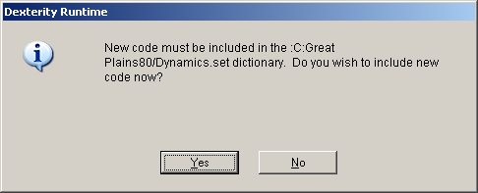
- Click the Yes button. The Login window will appear.
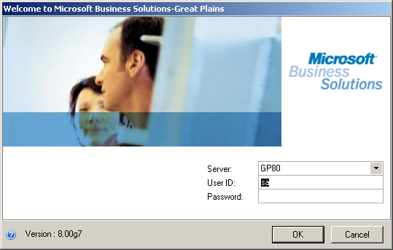
- Click to select the default server from the Server drop down list box and enter “sa” as your User ID then click the OK button. The Company Login window will appear.
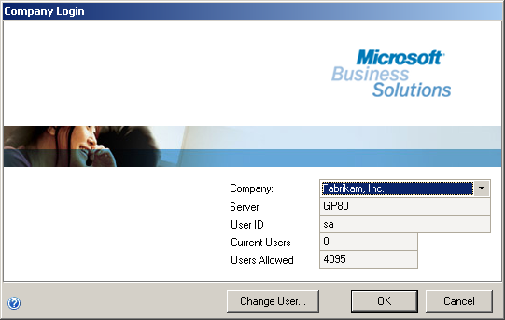
- Click to select the appropriate company from the Company drop down list box then click the OK button. The Microsoft Business Solutions - Great Plains main window will appear.

Table Creation
CWT Customization setup menu are contained in the CWT setup. It contains a fixed number of sub-menu items that will open windows which will be used for setting up the CWT Customization.
The following procedure describes how to create the CWT Customization tables.

To create tables:
- Open the CWT Create Tables window. (Tools>>Setup>>Company>>CWT Setup>>CWT Tables)
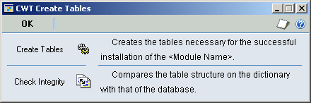
- Click Create Tables. A Table Creation log window will appear after a progress bar shows completion of the automatic table creation.
- Click OK to revert to the CWT Create Tables window then click OK.

Chapter 2: Working with CWT Customization
Once you’ve installed CWT Customization and set the requirements for the module, you can now easily process CWT Customization application.
In this section, you’ll learn:
- How to apply the CWT amount and how it is computed by the system
- How to create multi-rate CWT applications
- How to inquire and/or monitor CWT

Apply CWT
There are two conditions upon applying the CWT. One is when the cash receipts have not been posted in functional currency while the other is when the cash receipt have been posted.
For not posted cash receipts in functional currency, access the Cash Receipt window and create a cash receipt or retrieve an existing cash receipt.
For posted cash receipt, go directly to the Apply Sales Documents window then enter the customer ID and retrieve the cash receipt in Apply Sales Document using the Document No field or through the corresponding lookup window.

To apply the CWT for not posted cash receipts:
- Open the Cash Receipts Entry window. (Transactions>>Sales>>Cash Receipt)
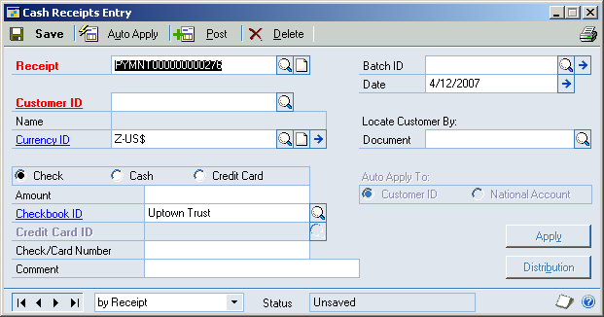
- Accept the default receipt number in the Receipt field or enter the appropriate number or click to select from the corresponding lookup window.
Enter the appropriate batch ID in the Batch ID field or click to select from the corresponding lookup window.
- Accept the default date in the Date field or enter the appropriate date and enter the appropriate customer ID in the Customer ID field or click to select from the corresponding lookup window then click the Apply button. The Apply Sales Documents window will appear.
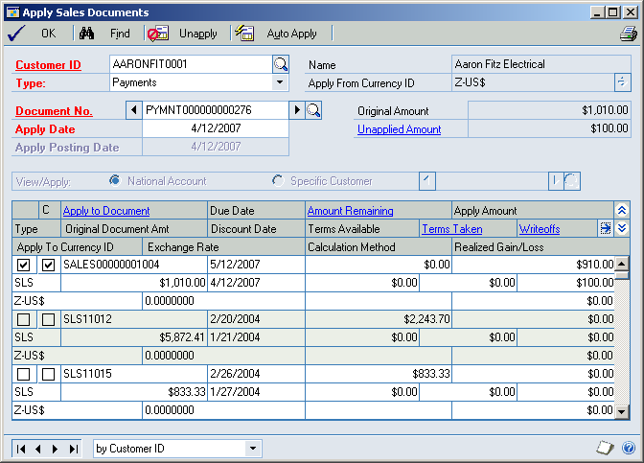
- Click the appropriate checkbox for the Sales Document in the Apply To column.
Click the next checkbox for the Sales Document beside the Apply To checkbox. The CWT Amount will be automatically computed and will be placed in Writeoffs field.
The next checkbox in the Apply To column has the label “C” which means CWT Apply.
- Click the CWT Expansion button beside the Writeoffs label in the header of the list. The CWT Computation window will appear.
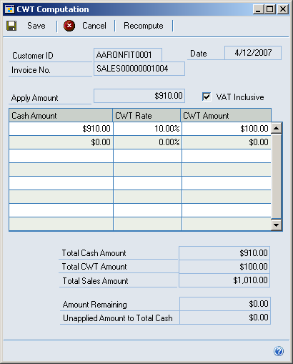
The CWT Computation window is where you can change the CWT Amount such as changing or removing the aggregate.
Change the amount CWT Amount if necessary.
The total Cash Amount should always equal to the Apply Amount.
- Click Save. You will revert to the Apply Sales Document window.
- Click OK.

Chapter 3: Generating CWT Customization Reports
Various reports can be generated for CWT Customization reporting. This chapter tackles where and how these reports can be generated out.
In this chapter, you’ll learn how to identify standard print options in Great Plains.

Generating Reports
The CWT Customization reports can be generated during setup and maintenance, or transaction entry and apply sales documents, or upon monitoring and/or inquiry of the CWT. There are two ways you can generate reports: using the File-Print menu option and from within the active or current window displayed.
You’ll be directed to the Report Destination window for all instances.
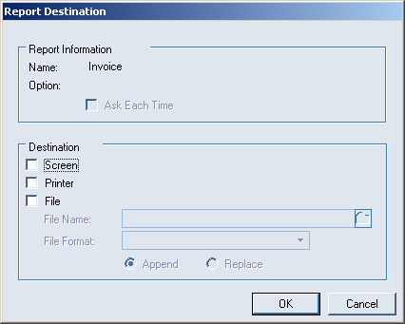
The Report Destination Window lets you determine where the report will be printed. There are three possible destinations for the report:
Destination | Description
Screen | Opens a Screen Output window displaying how the report looks like when printed.  You can also Click to print the report out to a printer from the Screen Output window.
Printer | Opens a Print window where you can specify the number of copies to be printed.
File | Selecting this in the Report Destination window activates the following fields and options:  File Name – specify the name of the report and the directory where the report will be saved.  File Format – specify the file format to be used in saving the report (Click from text file, tab-delimited, comma-delimited and HTML file).  Append – Click this option to append the report to an existing file.  Replace – Click this option to replace an existing file.
The printing options available are largely dependent on the reporting option provided by Microsoft Business Solutions - Great Plains.

Documentation Comment Form
CWT Customization User’s Guide
February 2006
We welcome your comments and suggestions regarding the quality of usefulness of this manual. Your comments help us improve the documentation to better meet your needs.
- Did you find any errors?
- Is the information clearly presented?
- Are the examples correct? Do you need more examples?
- What features do you like most (and least) about the documentation?
If you find errors or have specific suggestions, please note the topic, chapter and page number.
________________________________________________________________________________________________________________________________________________________________________________________________________________________________________________________________________________________________________________________________________________________________________________________________________________________________________________________________________________________________________________________________________________________________

Send your comments using any of the following:
E-mail | documentation@gisimplement.com
Fax | (632) 811 2225
Conventional mail | Documentation Team  2/F King’s Court II,  2129 Chino Roces Ave.,  Makati City 1231, Philippines
Thank you for taking the time to improve our documentation.

